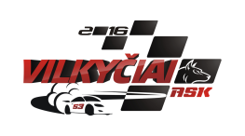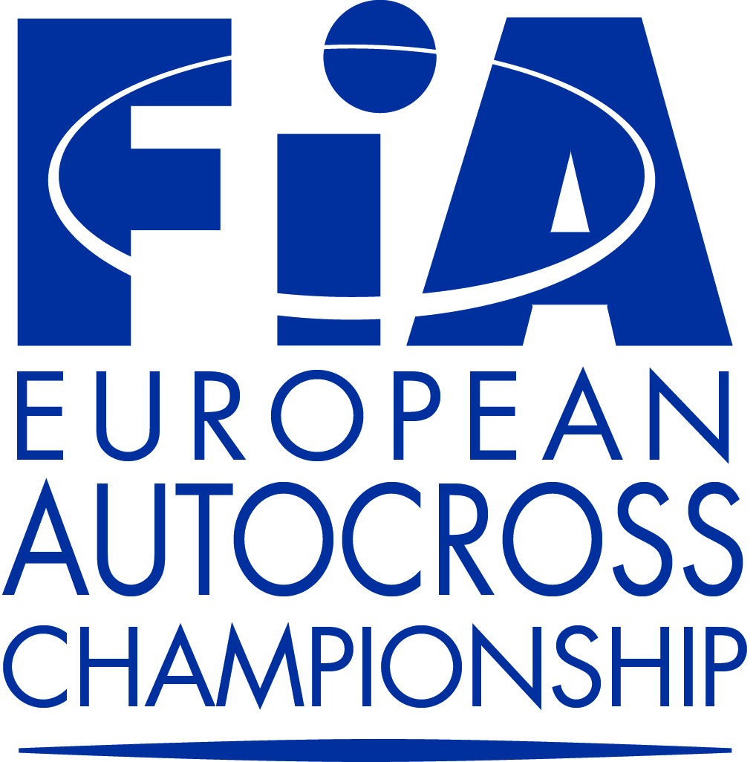
FIA European Autocross Championship
ENTRY FORM
EVENT: VILKYČIAI 2016 COUNTRY: LITHUANIA DATE: 03-05. 06. 2016

ORGANISER CLOSING DATE(S) FOR ENTRIES
Name: ASK „Vilkyčiai“ The entries must reach the organiser by:
Address: Minijos str. 27, Vilkyčiai, Lithuania 1. 20.05.2016 220 Eur.
Tel. +37069939290 2. 27.05.2016 275 Eur.
E-mail: vilkyciai.ask@gmail.com 3. After 2nd closing date 440 Eur.
4. National Cup – 120 Eur.

COMPETITOR
Name:................................................................
Nationality:.......................................................
Address:.............................................................
...........................................................................
Tel:....................................................................
Fax:....................................................................
E-mail:...............................................................
Division:
Tourning Autocross
Buggy 1600
Super Buggy
Junior Buggy
National Cup

Start number

Competition licence numbers:
Competitor:...........................................
Driver:...................................................
Signature
Competitor:.............................................
Driver:.....................................................
Date:........................................................

DRIVER
Name:.................................................................
Date of Birth:.....................................................
Nationality:.........................................................
Address:..............................................................
............................................................................
Tel:.....................................................................
Fax:.....................................................................
E-mail:................................................................

A.S.N. (Visa Stamp):

Marke ................................... Model...................... ................ cc............................... hp............................

FIA – Homologation Nº.............................. FIA Technical Passport Nº .....................................

Transponder nr .................................................

Turbo Yes 4WD Yes Weight ........................... kg
No No
We cnfirm that we have read and understood the provision of the International Sporting Code, The Autocross Technical Regulations and Autocross Sporting Regulations and we agree, on our own behalf and on behalf of everyone associated with our participation in the 2016 FIA European Autocross Championship, to observe and be bound by them (as supplemented or amended). We declare that we have examined this Entry Form and that the informatikon given is true, correct and complete. We understand that any change to the detais given on this Entry Form must be notified to the organiser.

